Lab 7 Loops

Instructions
- Answer the below question in the boxes if needed.
- Code on your computer and zip all your code before submission.
- Please submit the assignment after you finish.

Part 0 Preface
This lab would feel like a bit of brain teasers for people who are using loops for the first time. Some questions might require some time to think through the logic and quite some testing. Be patient and creative! If you are stuck, feel free to ask in office hours and lab sessions.



Part 1 Coding Exercise
Download the code package and unzip it. Then open the folder with Visual Studio Code.

You are required to complete or create some functions to fulfil the tasks. Please read the instructions carefully and finish all the tasks.

Make sure you test your code before submission. If you are not sure how to run the code, please check the steps in the previous labs.

Each of the exercise file is composed of the following parts:
- Task - exercise specifications
- Your code here - the place where you write your code
- Test case - a piece of code for you to run and test your function
- Expected output - if your code is successful, the console should output with this results

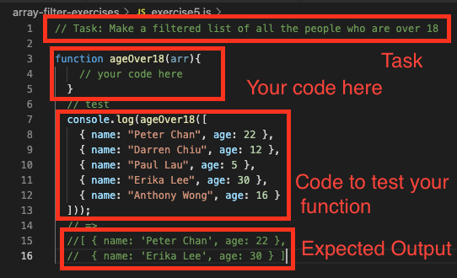

1.1 For Loops (01-for-loops)
You are required to complete all the exercises using for loops (including simple for loops, for/in loops, and for/of loops). No while loops is allowed.

1.2 While Loops (02-while-loops)
You would find the questions are exactly the same as 1.1 but you are required to complete all the exercises using while loops (including simple while loops, or do/while loops). No for loops is allowed.

1.3 Freestyle Challenging Questions (03-freestyle)
The questions in this part are challenging questions. They are harder than 1.1 and 1.2. Try your best to solve them using any loops you know. No restrictions for the types of loops to be used.

